**Server:**

import java.io.*;

import java.net.ServerSocket;

import java.net.Socket;

public class Server {

public static void main(String[] args) {

try {

ServerSocket obj = new ServerSocket(39);

while (true) {

Socket obj1 = obj.accept();

DataInputStream din = new DataInputStream(obj1.getInputStream());

DataOutputStream dout = new DataOutputStream(obj1.getOutputStream());

String str = din.readLine();

FileReader f = new FileReader(str);

BufferedReader b = new BufferedReader(f);

String s;

while ((s = b.readLine()) != null) {

System.out.println(s);

dout.writeBytes(s + "\n");

}

f.close();

dout.writeBytes("-1\n");

}

} catch (Exception e) {

e.printStackTrace();

}

}

}

**Client:**

import java.io.*;

import java.net.Socket;

public class Client {

public static void main(String[] args) {

try {

BufferedReader in = new BufferedReader(new InputStreamReader(System.in));

Socket clsct = new Socket("127.0.0.1", 39);

DataInputStream din = new DataInputStream(clsct.getInputStream());

DataOutputStream dout = new DataOutputStream(clsct.getOutputStream());

System.out.println("Enter File Name -> ");

String str = in.readLine();

dout.writeBytes(str+"\n");

System.out.println("Enter new File Name -> ");

String str2 = in.readLine();

String str1, ss;

FileWriter f = new FileWriter(str2);

char buffer[];

while (true) {

str1 = din.readLine();

if (str1.equals("-1")) {

break;

}

System.out.println(str1);

buffer = new char[str1.length()];

str1.getChars(0, str1.length(), buffer, 0);

f.write(buffer);

}

f.close();

clsct.close();

} catch (Exception e) {

e.printStackTrace();

}

}

}

**Server:**

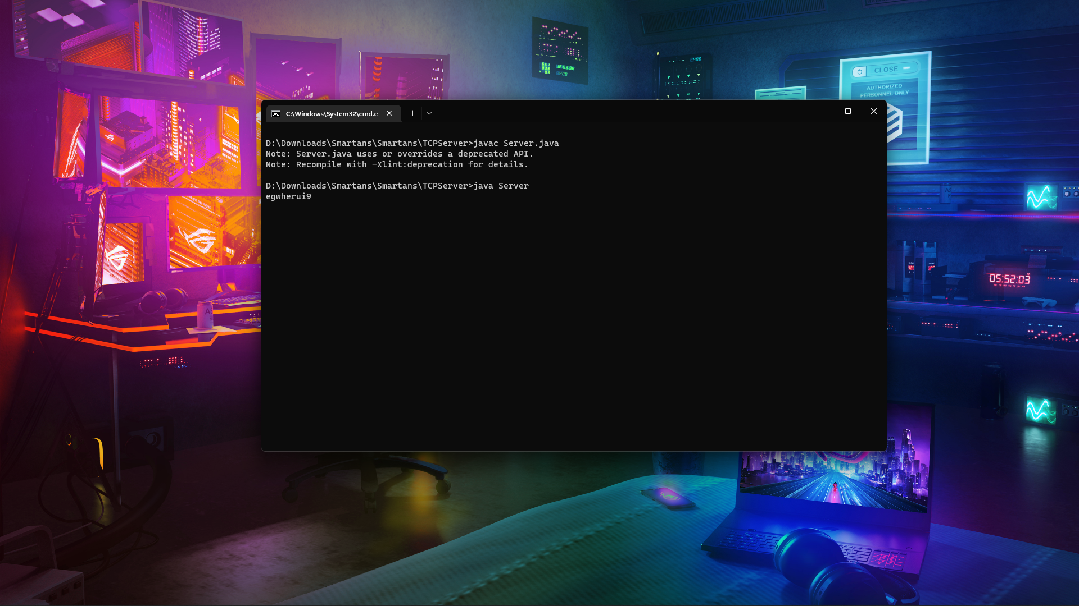

**Client :**

